Java Programs:-

1. A shop will give discount of 10% if the cost of purchased quantity is more than 1000.

Ask user for quantity

Suppose, one unit will cost 100.

Judge and print total cost for u

1. Given five positive integers, find the minimum and maximum values that can be calculated by summing exactly four of the five integers. Then print the respective minimum and maximum values as a single line of two space-separated long integers.

Example 1 2 3 4 5

The minimum sum is 1+2+3+4=10 and the maximum sum is 2+3+4+5=14. The function prints

1. Implement a java program to calculate gross salary and net salary taking the following data.

Input: empno, empname, basic

Process

DA=70% of basic

HRA=30% of basic

CCA= Rs. 240/-

PF=10% of basic

PT=Rs.100/-

1. Write a menu driven program to perform the following operations on one

dimensional array. (accept data from user)

a) to search a given element in an array

b) to sort elements in descending order

c) to delete the duplicate elements from an array

1. An Election is contested by 5 candidates. The candidate numbers are 1 to 5 and the voting is done by making the candidate number on the ballot paper. Write a program to read the ballots and count the vote for each candidate using and array variable count. In case, a number read is outside the range 1 to 5, the ballot should be considered as a ‘spoilt ballot ‘and the program should also count the number of spoiled ballots.
2. Given an unsorted integer array, find the first missing positive integer. Example,

If A = [-1, 4, 2, 3, 5], missing integer = 1.

If A = [1, 5, 2, 3, 4, 7], missing integer = 6.

If A = [-1, -2, -3, -4], missing integer = 1.

1. Caesar cipher is one of the simplest encryption technique. By using this cipher technique we can replace each letter in the plaintext with different one a fixed number of places up or down the alphabet.

For example :  
  
With right shift of 3:  
  
plaintext :      ABCDEFGHIJKLMNOPQRSTUVWXYZ  
  
ciphertext :    DEFGHIJKLMNOPQRSTUVWXYZABC

1. Write a constructor in the Car class given below that initializes the brand class field with the string “Ford”. Call the getBrand () method in the main method of the Sample class and store the value of the brand in a variable, and print the value.
2. Write a java program to create a user-defined package letmecalculate having class calculator and functions addition, subtraction, multiplication, division. Import this package in another program to use the class calculator.

1. WAP to find whether the entered 4 digit number is vampire or not. Combination of digits from this number forms 2-digit number. When they are multiplied by each other we get the original number. (1260=21*60, 1395=15*93, 1530=30*51)
2. Write a java program to count number of alphabets, digits, special symbols, blank spaces and words from the given sentence. Also count number of vowels and consonants
3. WAP that accepts a shopping list of items and performs the following operations: Add an item at a specified location, delete an item in the list, and print the contents of the vector
4. WAP to implement three classes namely Student, Test and Result. Student class has member as rollno, Test class has members as sem1_marks and sem2_marks and Result class has member as total. Create an interface named sports that has a member score (). Derive Test class from Student and Result class has multiple inheritances from Test and Sports. Total is formula based on sem1_marks, sem2_mark and score.

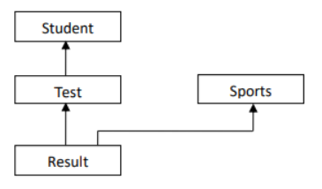

1. Create the Account class Account.java and write a main method in a different class to briefly experiment with some instances of the Account class. Using the Account class as a base class, write two derived classes called SavingsAccount and CurrentAccount.A SavingsAccount object, in addition to the attributes of an Account object, should have an interest variable and a method which adds interest to the account. A CurrentAccount object, in addition to the attributes of an Account object, should have an overdraft limit variable. Ensure that you have overridden methods of the Account class as necessary in both derived classes.Now create a Bank class, an object of which contains an array of Account objects. Accounts in the array could be instances of the Account class, the SavingsAccount class, or the CurrentAccount class. Create some test accounts (some of each type).Write an update method in the bank class. It iterates through each account, updating it in the following ways: Savings accounts get interest added (via the method you already wrote); CurrentAccounts get a letter sent if they are in overdraft.The Bank class requires methods for opening and closing accounts, and for paying a dividend into each account. Hints:Note that the balance of an account mayonly be modified through the deposit(double) and withdraw(double) methods.

The Account class should not need to be modified at all. Be sure to test what you have done after each step.

1. Write a Java Program to calculate the Result. Result should consist of name, seatno, date, center number and marks of semester three exam. Create a User Defined Exception class MarksOutOfBoundsException, If Entered marks of any subject is greater than 100 or less than 0, and then program should create a user defined Exception of type MarksOutOfBoundsException and must have a provision to handle it
2. Write a Java Program to input the data through command Line and Find out total valid and

in-valid integers. (Hint: use exception handling)

1. Write java program to implement the concept of Thread Synchronization(Ticket Booking Example)

Scala Problem Statements

1. Write a program to print given no in words using pattern matching and while loop .eg 123 output one two three.
2. Write a program to find whether the no is prime or not using do while loop.
3. Write a program in Scala to demonstrate string interpolation.
4. Create a class employee with data member empid, empname, designation and salary. Write a methods get_employee()-to take user input, show_grade –to display grade of the employee based on salary.

Show employee () to display employee details.

|  |  |
| --- | --- |
| 1. Salary Range | 1. Grade |
| 1. <10000 | 1. D |
| 1. 10000-24999 | 1. C |
| 1. 25000-49999 | 1. B |
| 1. >50000 | 1. A |

1. Five Bikers compete in a race such that they Drive at Constant speed which may or may not be same as the other. To qualify the race, the speed of as racer must be more than the average speed of all 5 racers. Write Scala program to take as an input the speed of all racer and print back the speed of qualifying racer.
2. Create a class named 'Member' having the following members:

Data members   
1 - Name   
2 - Age   
3 - Phone number   
4 - Address   
5 – Salary

 It also has a method named 'printSalary' which prints the salary of the members.   
Two classes 'Employee' and 'Manager' inherits the 'Member' class. The 'Employee' and 'Manager' classes have data members 'specialization' and 'department' respectively. Now, assign name, age, phone number, address and salary to an employee and a manager by making an object of both of these classes and print the same.

1. Design a class hierarchy rooted in the class Employee that includes subclasses for HourlyEmployee and SalaryEmployee. The attributes shared in common by these classes include the name, and job title of the employee, plus the accessor and mutator methods needed by those attributes. The salaried employees need an attribute for weekly salary, and the corresponding methods for accessing and changing this variable. The hourly employees should have a pay rate and an hours worked variable. There should be an abstract method called calculateWeeklyPay (), defined abstractly in the superclass and implemented in the subclasses. The salaried worker's pay is just the weekly salary. Pay for an hourly employee is simply hours worked times pay rate.
2. Write a recursive function to get the nth Fibonacci number. The first two Fibonacci numbers are 0 and 1. The nth number is always the sum of the previous two—the sequence begins 0, 1, 1, 2, 3, 5.  def fib (n: Int): Int
3. Write a function to find the values of following series: -Value=a+a2/2! +a3/3! +a4+4!................an/n! (use passing function as parameter to another function)
4. Write a Scala program to compute the sum of the two given integer values. If the two values are the same, then return triples their sum. (use anonymous function)
5. Write a Scala program to check whether a given positive number is a multiple of 3 or a multiple of 7
6. Create an abstract class 'Bank' with an abstract method 'getBalance'. $100, $150 and $200 are deposited in banks A, B and C respectively. 'BankA', 'BankB' and 'BankC' are subclasses of class 'Bank', each having a method named 'getBalance'. Call this method by creating an object of each of the three classes.
7. We have to calculate the area of a rectangle, a square and a circle. Create an abstract class 'Shape' with three abstract methods namely 'RectangleArea' taking two parameters, 'SquareArea' and 'CircleArea' taking one parameter each. The parameters of 'RectangleArea' are its length and breadth, that of 'SquareArea' is its side and that of 'CircleArea' is its radius. Now create another class 'Area' containing all the three methods 'RectangleArea', 'SquareArea' and 'CircleArea' for printing the area of rectangle, square and circle respectively. Create an object of class 'Area' and call all the three methods.
8. We have to calculate the percentage of marks obtained in three subjects (each out of 100) by student A and in four subjects (each out of 100) by student B. Create an abstract class 'Marks' with an abstract method 'getPercentage'. It is inherited by two other classes 'A' and 'B' each having a method with the same name which returns the percentage of the students. The constructor of student A takes the marks in three subjects as its parameters and the marks in four subjects as its parameters for student B. Create an object of the two classes and print the percentage of marks for both the students.
9. Create an abstract class 'Bank' with an abstract method 'getBalance'. $100, $150 and $200 are deposited in banks A, B and C respectively. 'BankA', 'BankB' and 'BankC' are subclasses of class 'Bank', each having a method named 'getBalance'. Call this method by creating an object of each of the three classes.

GUI Question:

WA program with4swing buttons with suitable texts on them. When the user presses a button a message should appear in the label as to which button was pressed by the user

Write java program to create a registration form using Swing

Write a program to search the string in the given program, display number of occurrences of string and replace the string with new string

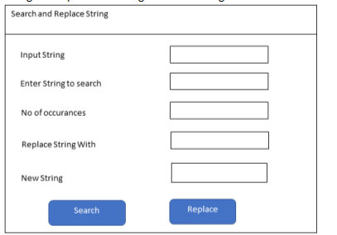

Write JavaScript program to display the even nos and odd nos from the given list

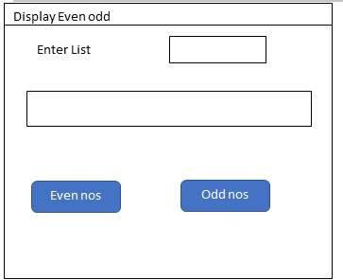

Write a java program using Swing to implement following

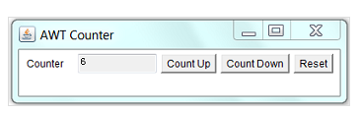

Write a Swing application called SwingAdder as shown. The "ADD" button adds the two integers and display the result. The "CLEAR" button shall clear all the text fields.

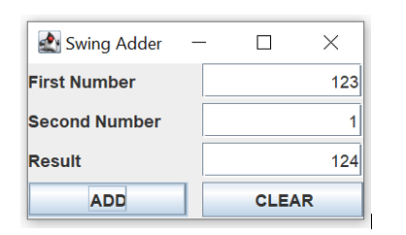

Write java program to Implement the following

